
COMSATS University Islamabad (CUI)

Software Design Specification

for
Pureplay

By
Syed Zubair CIIT/SP23-BCS-094/ISB
Maaz Bin Rashid CIIT/SP22-BAI-023/ISB

Supervisor
Ms. Farah Saeed

Co-Supervisor
Ms. Anum Zahra

Bachelor of Science in Computer Science (2023-2027)
Bachelor of Science in Artificial Intelligence (2022-2027)

Revision History
Name | Date | Reason for changes | Version

Application Evaluation History

Comments (by committee)  *include the ones given at scope time both in doc and presentation | Action Taken

Supervised by
Supervisor’s Name
Signature___________
Table of Contents
Abstract ii
1. Introduction 1
1.1 Overview of the Project 1
1.2 Vision Statement 1
1.3 Problem Statement 1
1.4 Problem Solution 2
1.5 Objectives of the Proposed System 2
1.6 Scope 3
1.6.1 Limitations and Constraints 3
1.7 Modules 3
Module 1.7.1: 3
• FE-1: 4
• FE-2: 4
• FE-3: 4
• FE-4: 4
Module 1.7.2: 4
• FE-1: 4
1.7.1 Related System Analysis 5
1.8 Tools and Technologies 6
1.9 Project Contribution 7
2. Chapter 2: Design Methodology and Software Process Model 8
2.1 Design Methodology: Object-Oriented Development (OOD) 8
2.2 Software Process Model: Agile (Scrum-Inspired Iterative) 8
2.3 Justification Summary 10
3. Chapter 3 10
3.1 Design and Architecture 10
3.2 System Architecture Overview 10
3.2.1 Purpose 11
3.2.2 Technologies and Services 11
3.3 Architecture Style and Pattern 13
3.3.1 The Five Layers Described 14
3.3.2 Justification for Layered Architecture 14
3.3.3 Component Interaction 15
3.4 Design Models 15
3.4.1 Activity Diagrams 15
3.4.2 Activity Diagram 2: Guardian Review and Override Flow 17
3.4.3 Activity Diagram 3: User Authentication Flow 18
3.4.4 Class Diagram 19
3.4.5 Sequence Diagrams 20
3.4.6 State Transition Diagram: Video Moderation Lifecycle 24
4. Data Design 24
4.1.1 Data Transformation and Organisation 24
4.1.2 Key Data Entities 25
4.1.3 Data Storage Systems 26
5. Chapter 4: Implementation 27
5.1 Project Methodology and Algorithms 27
5.1.1 Step-by-Step Agile Approach 27
5.1.2 Algorithms 28
5.2 Training Results and Model Evaluation 30
5.3 Security Techniques 30
5.4 External APIs and SDKs 31
5.5 User Interface 32
5.5.1 Registration Screen 32
5.5.2 Login Screen 34
5.5.3 Guardian Dashboard 34
5.5.4 Video Upload Portal 35
5.5.5 Admin Review Modal 36
5.6 Deployment 36
Testing and Evaluation 37
6. Chapter 5: Testing and Evaluation 37
6.1 Unit Testing 37
6.2 Functional Testing 39
6.3 Business Rules Testing 42
6.4 Integration Testing 44

Abstract
User-generated content is growing faster than platforms can keep up with, and manual moderation just isn't cutting it anymore. When videos get uploaded around the clock, relying on community reports to catch inappropriate content means harmful media is often already out there before anyone acts on it. This reactive approach doesn't just create unsafe spaces — it puts real psychological strain on the people doing the reviewing and opens platforms up to serious legal risk.
PurePlay was built to fix this. Instead of waiting for problems to surface, it intercepts every video at the moment of upload, runs it through an AI-powered pipeline, and flags anything that violates safety policies before it ever goes live. Admins get a clean dashboard where they can review flagged content, approve what's safe, and manage user accounts — all in one place. The result is a system that's proactive rather than reactive, and one that takes the burden of manual review down significantly. On the technical side, PurePlay is built as a React single-page application using Firebase Authentication, Cloud Firestore, and Cloud Storage to keep everything secure, fast, and scalable without needing a traditional server setup.
Abbreviations:
Abbreviation | Description
API | Application Programming Interface
BaaS | Backend-as-a-Service
FR | Functional Requirement
JWT | JSON Web Token
SPA | Single Page Application
UI/UX | User Interface / User Experience
ML | Machine Learning
CV | Computer Vision
NoSQL | Not Only SQL
SDLC | Software Development Life Cycle

Figure # | Title | Section
Figure 1 | Admin Use Case Diagram | 2.4
Figure 2 | Standard User Use Case Diagram | 2.4
Figure 3 | Module 1 — User Onboarding Mockup | 2.6.1
Figure 4 | Module 2 — Video Upload Mockup | 2.6.2
Figure 5 | Module 3 — Admin Dashboard Mockup | 2.6.3
Figure 6 | System Architecture Diagram | 3.1
Figure 7 | Layered Architecture Diagram | 3.3
Figure 8 | Activity Diagram – Video Upload and Processing Pipeline | 3.4.1
Figure 9 | Class Diagram – Full System Models and Services | 3.4.1
Figure 10 | Sequence Diagram – Video Upload Flow | 3.4.1
Figure 11 | Sequence Diagram – Admin Moderation Flow | 3.4.1
Figure 12 | State Machine Diagram – Video Moderation Lifecycle | 3.4.1
Figure 13 | Entity Relationship Diagram (ERD) | 3.5
Figure 14 | Login Screen UI | 4.5
Figure 15 | Registration Screen UI | 4.5
Figure 16 | Main User Upload Screen UI | 4.5
Figure 17 | Admin Dashboard Flagged Content Screen UI | 4.5
Figure 18 | Modal Video Review UI | 4.5

Introduction
This chapter sets the stage for understanding what PurePlay is, why it was built, what problem it solves, and how it goes about solving it. It also looks at similar systems that already exist and outlines the tools and technologies used to build it

Overview of the Project
Pureplay is an AI-powered, web-based video moderation platform built for platform administrators, community managers, and digital content operators who require structured, automated filtering of user-generated media before it becomes publicly accessible. The platform accepts a user's video upload and systematically processes it through an AI censorship intelligence pipeline powered by the Google Cloud Video Intelligence API, which performs frame-level explicit content detection across categories including adult content, violence, and graphic material. Each uploaded video is automatically assigned a moderation status of Approved, Flagged, or Rejected based on confidence thresholds returned by the API. The entire classification pipeline is orchestrated through Firebase Cloud Functions—serverless event-driven triggers that fire automatically upon successful upload to Cloud Storage, invoke the Video Intelligence API, parse the classification response, and persist the moderation verdict to Cloud Firestore without any manual intervention.
The platform is delivered as a React.js Single Page Application (SPA) backed by a fully serverless Firebase architecture comprising Firebase Authentication, Cloud Firestore, Cloud Storage, and Cloud Functions. Its eight modules take a user from secure authentication through to a content-safe public gallery, replacing what would otherwise be hours of manual queue review and psychological exposure with an automated pipeline that runs at upload time and presents findings through an interactive Admin Dashboard. By automating content screening, status assignment, and administrative oversight, Pureplay reduces moderation latency from days to seconds.

Vision Statement
For digital communities and platform administrators who struggle to maintain safe, policy-compliant environments amidst an overwhelming volume of user-generated video content, Pureplay is an AI-assisted video moderation platform that transforms raw media intake into a secure, filtered content stream. Unlike fragmented approaches that rely solely on reactive community reporting or disconnected third-party AI APIs requiring heavy custom backend integration, our product automatically intercepts video uploads at the point of submission, invokes the Google Cloud Video Intelligence API via serverless Cloud Functions to classify content against strict censorship policies, and surfaces only high-risk content for human review, dramatically increasing platform trust, reducing moderator psychological burden, and ensuring that inappropriate media never reaches the public domain.

Problem Statement
As user-generated video has exploded across platforms, keeping up with it has become nearly impossible for most administrators. Without any structured screening at the point of upload, most platforms fall back on manual review or community reporting — approaches that are both slow and deeply flawed. Harmful content ends up sitting in public view while the review process plays catch-up.
Manual review is also tough on the people doing it. Watching hours of flagged content — some of it genuinely disturbing — takes a real psychological toll. Burnout and trauma are well-documented risks for human moderators who are regularly exposed to violent or explicit material.
The tools that exist today don't really solve this either. Community reporting assumes harm must first be witnessed before it can be removed. Standalone AI APIs like AWS Rekognition or Google Cloud Video Intelligence are powerful, but they don't come with an interface — integrating them requires significant backend work and technical expertise that many platform operators simply don't have. None of these tools cover the full moderation workflow from intake to resolution in one place.
That's the gap PurePlay addresses: a single, unified system that handles everything from upload to review to administrative action, without requiring a technical background to operate.

Problem Solution
Pureplay acts as an intelligent gatekeeper and co-pilot for platform moderation. The platform ingests user uploads via Firebase Cloud Storage, which automatically triggers a Firebase Cloud Function upon successful file write. This Cloud Function invokes the Google Cloud Video Intelligence API to perform frame-level explicit content detection, parsing the API response for confidence scores across categories such as EXPLICIT, VERY_LIKELY, and POSSIBLE. Based on configurable confidence thresholds, the function writes a moderation verdict (Approved, Flagged, or Rejected) to the corresponding Firestore document. All findings are presented through an intuitive Admin Dashboard, guiding the moderator through flagged content review, severity assessment, approval or rejection overrides, and user account management. By automating the initial detection and classification phase, Pureplay reduces moderation time from days to seconds and transforms a reactive, report-based moderation culture into a proactive, AI-defended ecosystem where harmful content is intercepted at the boundary.

Objectives of the Proposed System
BO-1: Reduce manual video review time significantly through automated AI censorship using Google Cloud Video Intelligence API and Firebase Cloud Function orchestration at the point of upload.
BO-2: Provide a seamless, secure video uploading experience for end-users utilizing highly scalable Firebase Cloud Storage with real-time chunked progress tracking.
BO-3: Implement a robust, Firebase Authentication-backed identity and session management system with strict role-based access control (RBAC) separating Standard Users from Administrators.
BO-4: Deliver a comprehensive Admin Dashboard for monitoring system-wide insights, including total uploads, flag ratios, approval counts, and historical video moderation logs with real-time Firestore synchronization.
BO-5: Enable secure, sandboxed real-time video playback and manual review overrides for AI-flagged content via a modal-based review interface, ensuring administrators can safely inspect flagged media without full-screen exposure.
BO-6: Ensure highly scalable and resilient metadata management using a NoSQL cloud document database (Firestore) with real-time WebSocket synchronization across all connected clients.
BO-7: Equip administrators with user management capabilities including upload history tracking, flag count monitoring, and the ability to suspend or ban users who repeatedly violate platform content policies.

Scope
Pureplay is a web-based platform comprising a frontend interactive React SPA and a fully serverless Firebase + Google Cloud backend. The frontend handles user authentication, video uploads, content gallery browsing, profile management, and administrative dashboards. The backend manages secure binary object storage (Cloud Storage), real-time document database synchronization (Cloud Firestore), identity management (Firebase Authentication), and event-driven AI pipeline execution (Cloud Functions invoking Google Cloud Video Intelligence API). The system utilizes structured NoSQL document storage and event-driven Cloud Function triggers for managing AI analysis upon upload.
The platform is strictly scoped to recorded video content moderation and does not include live streaming moderation, audio-only analysis, or image-specific classification. The intelligence foundation relies on the Google Cloud Video Intelligence API's EXPLICIT_CONTENT_DETECTION feature, which performs shot-level and frame-level likelihood scoring across categories including adult, violent, and graphic material. All moderation decisions are surfaced to human administrators for final override authority, ensuring a human-in-the-loop paradigm.

Limitations and Constraints
LI-1: AI moderation accuracy depends on the Google Cloud Video Intelligence API's underlying model; false positives and false negatives will inherently occur, necessitating human-in-the-loop review for all flagged content.
LI-2: Video upload sizes, bitrates, and processing speeds are constrained by client-side bandwidth limitations and Firebase Cloud Storage quota configurations (default maximum: 100 MB per file).
LI-3: The system is heavily reliant on a continuous internet connection for real-time Firestore WebSocket synchronization; offline functionality is limited to the Firebase SDK's local cache, and uploads cannot proceed without network connectivity.
LI-4: Browser compatibility is restricted to modern stable versions of Google Chrome, Mozilla Firefox, Microsoft Edge, and Safari (current and one prior stable release).
LI-5: Google Cloud Video Intelligence API usage incurs per-minute billing for video analysis; the prototype demonstration operates within the free-tier quota, which may limit the volume of videos that can be processed during evaluation.
LI-6: Cloud Function cold-start latency may introduce a delay of 2–5 seconds before the AI analysis begins on the first invocation after an idle period.
LI-7: The prototype demonstration operates on Firebase's free-tier (Spark/Blaze Plan) infrastructure; production-scale deployment would require billing plan upgrades for sustained high-volume usage.

Modules
Pureplay is composed of eight comprehensive functional modules, each scoped to a distinct stage of the moderation and user workflow.
Module 1.7.1: User Authentication and Onboarding
FE-1: Secure user registration and login utilizing Firebase Authentication with support for email/password and Google OAuth sign-in providers.
FE-2: Strict role-based access control (RBAC) distinguishing Admin privileges from Standard Users via Firestore-stored role attributes.
FE-3: Session persistence and JSON Web Token (JWT) management handled natively by the Firebase SDK, with automatic token refresh.
FE-4: Password recovery via Firebase's secure email-based reset flow and secure profile management features.
Module 1.7.2: Secure Video Intake Pipeline
FE-1: Drag-and-drop interface for secure video file uploads with MIME type validation restricted to video/mp4 and video/webm.
FE-2: Rich metadata collection (title, description) linked securely to the video asset and uploader identity.
FE-3: Real-time chunked upload progress indicators driven by Firebase upload task snapshot observers.
FE-4: Automatic generation of signed download URLs upon successful binary transfer.
Module 1.7.3: AI Content Moderation Engine
FE-1: Automated Firebase Cloud Function trigger that fires upon successful video upload to Cloud Storage, invoking the Google Cloud Video Intelligence API's EXPLICIT_CONTENT_DETECTION feature.
FE-2: Frame-level likelihood classification across categories: VERY_UNLIKELY, UNLIKELY, POSSIBLE, LIKELY, VERY_LIKELY for adult, violent, and graphic content.
FE-3: Algorithmic confidence threshold evaluation: if any frame returns LIKELY or VERY_LIKELY for explicit content, the video is automatically flagged.
FE-4: Automatic Firestore document update with moderation verdict (Pending → Flagged or Approved), AI confidence scores, and analysis timestamp.
Module 1.7.4: Administrative Insight Dashboard
FE-1: A unified home screen featuring high-level system metrics including Total Uploads, Flagged Count, Approved Count, and Active Users.
FE-2: Interactive data visualization cards representing platform health statistics with real-time Firestore snapshot synchronization.
FE-3: Navigation to dedicated management views for Videos, Users, and System Settings.
Module 1.7.5: Flagged Content Review System
FE-1: A dedicated flagged-content queue displaying high-priority AI-detected violations ordered by upload timestamp or AI severity score.
FE-2: Modal-based, sandboxed video player for safe administrative review, preventing accidental full-screen exposure.
FE-3: Manual override controls (Approve/Delete) updating Firestore document status in real-time.
FE-4: Audit-ready logging of administrative override actions.
Module 1.7.6: Public Content Gallery
FE-1: Authenticated gallery displaying only safely approved videos to Standard Users.
FE-2: Responsive, accessible UI optimized for both mobile and desktop viewing with Tailwind CSS utility-first styling.
FE-3: Search and filtering capabilities based on video metadata (title, upload date, uploader).
Module 1.7.7: User Management System
FE-1: Administrative interface to view all registered users with profile details, registration date, and upload history.
FE-2: Ability to suspend or ban users who repeatedly violate platform content policies.
FE-3: Tracking of user-specific upload histories and cumulative flag counts.
Module 1.7.8: System Configuration and Reporting
FE-1: Export functionality to generate moderation activity reports.
FE-2: Administrative configuration of AI sensitivity thresholds (e.g., adjusting the LIKELY vs VERY_LIKELY cutoff for auto-flagging).

Related System Analysis and Literature Review

Literature Review
Prior research on content moderation consistently identifies two primary failure modes in digital platforms: administrators either skip moderation entirely due to overwhelming volume, or they rely on tools that are too disconnected and narrow in scope to provide meaningful efficiency gains. Traditional methodologies rely heavily on reactive community reporting—an approach that inevitably allows harmful content a window of public exposure, damaging platform reputation, eroding user trust, and creating legal liability. Research by Gillespie (2018) in "Custodians of the Internet" documents the immense psychological toll of manual content moderation on human reviewers, establishing a clear need for automated pre-screening to reduce human exposure to toxic media. More recent studies by Gorwa, Binns, and Katzenbach (2020) demonstrate that integrating automated machine learning models at the intake stage can intercept up to 95% of explicit material before publication, provided the models are supplemented by human oversight for edge cases.
The technical foundation of Pure Play’s moderation pipeline is informed by established computer vision research. Convolutional Neural Networks (CNNs), as demonstrated in foundational work by Krizhevsky, Sutskever, and Hinton (2012), have proven highly effective for image and frame-level classification tasks. Google's Cloud Video Intelligence API builds upon these advances, providing production-grade explicit content detection that performs shot-level and frame-level analysis using pre-trained deep learning models, requiring no custom model training or infrastructure provisioning from the developer. PurePlay's architecture leverages this API through Firebase Cloud Functions—serverless event-driven triggers that eliminate the need for dedicated backend servers and enable seamless integration within the Firebase ecosystem.
Existing tools and platforms fail to integrate these capabilities into a unified workflow. Manual forum moderation is unstructured and psychologically damaging. Reactive reporting systems create unavoidable windows of harmful exposure. Standalone AI APIs, when used in isolation, offer powerful classification but require substantial custom integration and provide no administrative UI. Pureplay addresses this gap by providing an automated, end-to-end pipeline that combines secure video intake, Cloud Function-orchestrated AI classification, administrative review, and content publication within a single platform specifically designed for non-technical platform operators.

Related System Analysis

Application Name | Weakness | Proposed Project Solution
Manual Forum Moderation | Unstructured; time-consuming to watch hours of content; highly prone to human error, cognitive bias, and extreme psychological strain on moderators. | Pureplay automates the initial screening via Google Cloud Video Intelligence API invoked through serverless Cloud Functions, presenting human moderators only with high-risk, flagged content, significantly reducing psychological exposure and review time.
Reactive Report Systems (e.g., standard YouTube/Facebook model) | Harmful content is published and publicly accessible until a sufficient number of users report it, causing unmitigated user exposure and platform damage before any removal action is enacted. | Pureplay evaluates content strictly at the intake stage via event-driven Cloud Function triggers firing upon Cloud Storage upload completion, preventing flagged media from ever reaching the public content gallery.
Disconnected AI APIs (e.g., AWS Rekognition used standalone) | Requires heavy custom backend integration, cloud infrastructure provisioning, and manual database wiring. Provides no built-in UI for human-in-the-loop override, making it impractical for non-technical administrators. | Pureplay wraps the Google Cloud Video Intelligence API inside Firebase Cloud Functions, connecting it natively to Cloud Storage and Firestore, and presents results through a fully integrated React Admin Dashboard requiring zero infrastructure management.

Tools and Technologies
Table 1.2: Tools and Technologies for the Proposed Project
Category | Tool/Technology | Version | Rationale & Purpose of Usage
Tools | VS Code | Latest | Primary IDE for all frontend and Cloud Function development.
 | Firebase Console | Latest | Web-based administration console for managing Auth, Firestore, Storage, Functions, and security rules.
 | Google Cloud Console | Latest | Configuration and monitoring of Video Intelligence API quotas, billing, and Cloud Function logs.
Frontend | React.js | v19.2 | High-performance frontend library utilizing virtual DOM for building the dynamic SPA UI and Admin Dashboard.
 | Vite (Rolldown) | v7.2 | Ultra-fast frontend build tool providing instant HMR for development and optimized production bundles.
 | Tailwind CSS | v4.3 | Utility-first CSS framework enforcing a modern, responsive UI design system across all screens.
 | React Router DOM | v7.15 | Client-side routing for protected route guards, role-based navigation, and deep-linkable SPA pages.
 | Framer Motion | v12.38 | Production-grade animation library for smooth micro-animations and page transitions.
 | Lucide React | v1.14 | Consistent, modern SVG icon library used across the entire platform UI.
Backend (Serverless) | Firebase Authentication | Latest | Secure identity management: email/password, Google OAuth, JWT session tokens, automatic token refresh.
 | Firebase Cloud Firestore | Latest | NoSQL document database providing real-time WebSocket synchronization for user metadata, video logs, and moderation status.
 | Firebase Cloud Storage | Latest | Highly scalable binary object storage for video file uploads with chunked transfer and signed URL generation.
 | Firebase Cloud Functions | Latest | Serverless Node.js runtime for event-driven backend logic; triggers upon Storage upload to orchestrate the AI pipeline.
AI / ML | Google Cloud Video Intelligence API | Latest | Pre-trained deep learning API performing frame-level explicit content detection (EXPLICIT_CONTENT_DETECTION) across adult, violent, and graphic categories. Returns per-frame likelihood scores.

Project Contribution
Pureplay makes several concrete technical and conceptual contributions that distinguish it from existing solutions:
Proactive Intake-Stage Moderation Pipeline: Unlike reactive report-based systems, Pureplay intercepts and classifies content at the exact moment of upload via event-driven Cloud Functions invoking Google Cloud Video Intelligence API, ensuring harmful content never enters the public domain. This represents a fundamental architectural shift from "detect-after-exposure" to "classify-before-publication."
Fully Serverless Event-Driven Architecture: Utilizes Firebase Backend-as-a-Service (BaaS) combined with Cloud Functions to completely eliminate traditional server infrastructure overhead, ensuring high availability, zero-maintenance auto-scaling, and globally distributed data replication without requiring DevOps expertise.
Seamless AI-to-Database Pipeline: Cloud Functions bridge the Google Cloud Video Intelligence API directly to Firestore, creating an unbroken automated flow: Upload → Storage Trigger → Cloud Function → Video Intelligence API → Firestore Status Update → Real-Time Dashboard Refresh—with zero manual intervention.
Human-in-the-Loop AI Paradigm: Balances the rapid efficiency of Google's pre-trained classification models with the nuanced, context-aware oversight of human administrators through a dedicated modal-based review interface, effectively addressing the "false positive" dilemma inherent in all automated classification systems.
Integrated End-to-End Moderation Workspace: Combines secure authentication, video intake, AI classification, administrative review, user management, and content publication into a single, unified platform accessible to non-technical operators.
1.11 Relevance to Course Modules
Web Technologies: Developed a high-performance interactive dashboard using React.js and Vite, implementing complex state management via React Context API (useAuth), custom hooks, and client-side routing with protected route guards.
Database Systems: Implementation of NoSQL document modeling, denormalization strategies, real-time WebSocket synchronization via Cloud Firestore, and Firestore Security Rules for edge-level authorization enforcement.
Artificial Intelligence: Integration of Google Cloud Video Intelligence API for frame-level explicit content classification, event-driven AI pipeline orchestration via Cloud Functions, and confidence threshold-based automated decision making.
Software Engineering: Application of SDLC phases, modular layered architecture, Agile iterative methodology, mockup-based requirement analysis, rigorous unit/functional/integration testing, and comprehensive requirement documentation.
Cloud Computing: Practical deployment of serverless architecture using Firebase BaaS and Google Cloud Platform services, demonstrating event-driven function triggers, API integration, and cloud-native application design.

Chapter 2: Design Methodology and Software Process Model
This chapter explains and justifies the design methodology and software process model adopted for the development of Pureplay. These choices directly shape how the system is structured, how the two-member team collaborates, and how progress is measured and evaluated across the FYP-1 and FYP-2 delivery phases.

Design Methodology: Object-Oriented Development (OOD)
Pureplay follows an Object-Oriented Development (OOD) approach throughout its design and implementation. This choice is grounded in the nature of the system itself. Pureplay models a real-world domain with clearly identifiable entities, each with well-defined attributes, behaviors, and inter-entity relationships: User, Video, Child Profile, AnalysisResult, XAITimelineEvent, and Audit Log. The OOD approach allows these real-world concepts to be directly mapped onto software classes, making the codebase intuitive, maintainable, and extensible as the AI pipeline evolves across FYP phases.
The justification for choosing OOD over a procedural approach rests on four core arguments:
- Modularity and Encapsulation: Each system entity is encapsulated within its own class, hiding internal implementation details and exposing only well-defined interfaces. A change to the internal structure of the Analysis Result class, for example, does not cascade into unrelated parts of the system such as the authentication or dashboard modules.
- Separation of Concerns via Service Classes: Pureplay separates document model classes from service classes (AuthService, VideoIntakeService, CensorshipPipelineService, DashboardService, and so on). Each service class has a single, well-defined responsibility, directly implementing the Single Responsibility Principle (SRP). This is far more natural in OOD than in a procedural design where all logic would reside in monolithic functions.
- Reusability Without Duplication: Shared behavior, such as base MongoDB query patterns and common validation logic, is centralized and reused across service classes without code duplication, following the DRY (Do Not Repeat Yourself) principle.
- Alignment With the Technology Stack: Python Flask and Django, PyMongo, React.js, and Celery are all fundamentally object-oriented and component-based. Flask views, Django serializers, React components, and PyMongo document models are all objects with methods. Applying a procedural methodology to this stack would create unnecessary friction and result in poorly structured, untestable code.
The design models produced in Chapter 3, specifically the Class Diagram, Activity Diagrams, Sequence Diagrams, and State Transition Diagram, are all OOD-appropriate models as required by the CUI SDS template for Object-Oriented Development.

Software Process Model: Agile (Scrum-Inspired Iterative)
Pureplay adopts an Agile software process model, specifically a Scrum-inspired iterative approach, as its development process model. Agile is chosen over traditional waterfall or spiral models for the following reasons:
- Uncertain and Evolving AI Requirements: The performance characteristics of pre-trained AI models, specifically NudeNet, Whisper, and Detoxify, cannot be fully specified upfront without empirical testing against real video content. Agile's iterative nature allows the team to integrate each AI component incrementally, evaluate its real-world performance on test videos, and adjust sensitivity thresholds and pipeline logic based on observed results, rather than committing to fixed specifications that may prove incorrect.
- Two-Developer Parallel Workstreams: Pureplay is developed by two team members with partially overlapping responsibilities. The Agile sprint structure naturally decomposes the project into short, independently deliverable modules. One developer owns the frontend and API layer, the other owns the AI pipeline and data layer, with each sprint producing a testable, integrated increment. This minimizes integration conflicts and ensures continuous progress visibility.
- FYP Phase Gating: The CUI FYP structure is inherently iterative. FYP-1 delivers 30 percent of the system and FYP-2 delivers the remaining 70 percent. Agile's incremental delivery model aligns directly with this phase-gated structure, allowing each phase to deliver a functional and evaluable system increment rather than requiring all components to be complete before anything can be demonstrated.
- Continuous In-Sprint Testing: Agile's emphasis on testing within each sprint ensures that each module, authentication, video intake, and dashboard, is unit tested and functionally tested before the next sprint begins. This prevents defects from accumulating across sprints and reduces the cost of rework.

Sprint / Duration | Module | Key Tasks | Deliverable / Outcome
FYP-1 Sprint 1 (2 weeks) | Module 1: User Authentication and Onboarding | Guardian and Admin registration, email verification, bcrypt password hashing, JWT issuance, RBAC middleware, Child Profile creation and PIN setup. | Authenticated session with role-based dashboard redirection; Child Profile document persisted in MongoDB.
FYP-1 Sprint 2 (2 weeks) | Module 2: Secure Video Intake Pipeline | Video upload endpoint, MIME and magic byte validation, MinIO integration, MongoDB Video document creation, Celery task dispatch, FFmpeg frame and audio extraction. | Video binary stored in MinIO; MongoDB record created with status tracking; Celery worker executes preprocessing pipeline.
FYP-1 Sprint 3 (2 weeks) | Module 3: Guardian and Admin Dashboards | Guardian Dashboard (video status, Child Profile settings), Admin Dashboard (platform metrics, user management), Admin Review Modal (Approve and Reject override). | Functional dashboards rendering live data from MongoDB; Admin override action writes to AuditLog.
FYP-2 Sprint 4 (3 weeks) | Module 4: Visual AI Pipeline | NudeNet and OpenNSFW2 integration, per-frame CNN scoring, threshold comparison against ChildProfile, flagged timestamp extraction, AnalysisResult document creation. | Visual flagging pipeline operational; flagged frames recorded with confidence scores in MongoDB.
FYP-2 Sprint 5 (3 weeks) | Module 5: Audio AI Pipeline | Whisper STT transcription, Detoxify toxicity classification, severity scoring, audio segment flagging, XAITimelineEvent document generation. | Audio toxicity pipeline operational; transcribed and scored segments recorded in MongoDB.
FYP-2 Sprint 6 (3 weeks) | Module 6: Filtering Engine and XAI Timeline | Aggregation of visual and audio flags, blur and mute application via FFmpeg, filtered video export to MinIO, Guardian XAI transparency dashboard rendering. | Filtered video downloadable by Guardian; XAI timeline renders colour-coded detection events with human-readable reasoning strings.
Table 2.1: Agile Sprint Plan - Full Project (FYP-1 Sprints 1-3 Implemented; FYP-2 Sprints 4-6 Planned)

Justification Summary
Object-Oriented Design is chosen because PurePlay's domain naturally maps onto objects with attributes and behaviours, the technology stack is inherently object-oriented, and the system's modular service architecture demands encapsulation and single-responsibility design. Agile is chosen because AI component performance requires empirical iteration, the two-developer team benefits from sprint-based parallel workstreams, and the CUI FYP phase structure is itself iterative. Together, OOD and Agile provide the methodological foundation for delivering a high-quality, incrementally testable, and academically rigorous system across both FYP phases.

Chapter 3

Design and Architecture
This chapter presents the complete architectural design of the PurePlay system. It covers the system architecture, chosen architectural pattern, technologies, detailed design models, and data design. The architecture described here represents the full system blueprint for PurePlay as a unified, end-to-end AI-powered video filtering platform.

System Architecture Overview
PurePlay is built on a Component-Based Layered Architecture that connects three primary actor types, Guardian, Admin, and Child/Teen Viewer, to a unified web platform for AI-powered video content filtering. The architecture separates presentation, API gateway, service orchestration, AI processing, and data persistence concerns into five structurally distinct layers. This separation ensures each layer can evolve independently, security enforcement is centralised, and the computationally intensive AI pipeline does not block user-facing API responsiveness.
The system integrates two distinct AI detection modalities, CNN-based NSFW visual classification and NLP-based audio toxicity detection, orchestrated via an asynchronous event-driven task pattern using Celery and Redis. This architectural decision is a direct consequence of the processing model: video analysis is long-running and cannot block the HTTP request cycle. The result is a platform that accepts a video upload synchronously, dispatches analysis asynchronously, and makes the filtered output available once processing completes.

Purpose
To provide a conceptual view of the PurePlay system illustrating where each module resides, what technologies are used, and how data and control flow between system components. This includes the dual-modal AI censorship pipeline, age-aware child profile management, the Guardian and Admin portals, and the backend storage and orchestration infrastructure.

Architecture Component | Description | Technology Used | Security Mechanism
Presentation Layer | React.js Single-Page Application serving all actor portals: Guardian, Admin, and Child/Teen views. Renders dashboards, upload forms, and filtering reports. | React.js v18, Vite, Tailwind CSS | HTTPS/TLS 1.3, CORS policy, input sanitization, CSP headers
API Gateway Layer | Flask/Django REST backend receiving all client requests, validating JWT tokens, enforcing RBAC, and routing calls to internal services. | Python Flask or Django REST Framework | JWT Bearer Token, RBAC Middleware, input validation, rate limiting
Service / Orchestration Layer | Celery task queue coordinated by Redis broker. Manages asynchronous video processing jobs to prevent blocking the API layer. | Celery 5.x, Redis 7.x | Task isolation, signed task payloads, Redis AUTH
AI Processing Layer | Executes the dual-modal censorship pipeline: FFmpeg for extraction, NudeNet/OpenNSFW2 for visual CNN classification, Whisper for STT, Detoxify for NLP toxicity scoring. | FFmpeg, NudeNet/OpenNSFW2, OpenAI Whisper, Detoxify | Sandboxed FFmpeg execution, no internet egress from workers, model integrity hash checks
Data Persistence Layer | MongoDB stores all structured metadata. MinIO provides S3-compatible object storage for raw and filtered video binaries. | MongoDB 7.x (PyMongo), MinIO (S3-compatible) | TLS-encrypted connections, field-level encryption for PII, MinIO bucket policies, RBAC
Table 3.1: Architecture Components, Description, Technology Used, and Security Mechanism

Technologies and Services
The following table enumerates all technologies, frameworks, and services integrated into the PurePlay platform, the specific purpose each serves, and the architectural layer in which it operates.

Technology / Service | Description | Purpose of Usage | Location / Module
React.js 18 + Vite + Tailwind CSS | Modern frontend SPA framework with Vite bundler and Tailwind utility-first CSS. | Primary user interface for all portals | Presentation Layer
Python Flask / Django REST | Python web framework serving as the RESTful API backend handling all HTTP routes, authentication, and business logic. | Core backend API gateway | API Gateway Layer
Celery 5.x | Distributed task queue enabling asynchronous processing of long-running video analysis jobs. | Task orchestration and job scheduling | Service / Orchestration Layer
Redis 7.x | In-memory data structure store serving as the Celery message broker and result backend. | Celery broker and result caching | Service / Orchestration Layer
FFmpeg | Industry-standard multimedia processing tool for frame extraction and audio isolation. | Media preprocessing pipeline | AI Processing Layer
NudeNet / OpenNSFW2 | Pre-trained CNN-based NSFW image classification models scoring each extracted frame. | NSFW visual content detection | AI Processing Layer
OpenAI Whisper | State-of-the-art ASR model transcribing isolated audio tracks to text. | Audio speech-to-text transcription | AI Processing Layer
Detoxify | Transformer-based NLP toxicity classifier assigning severity scores to transcribed speech segments. | Audio toxicity and profanity classification | AI Processing Layer
MongoDB 7.x (PyMongo) | NoSQL document database storing all metadata: users, video records, analysis results, audit logs. | Primary metadata persistence | Data Persistence Layer
MinIO | S3-compatible self-hosted object store for raw uploaded videos, extracted frames, and filtered exports. | Binary object storage | Data Persistence Layer
bcrypt | Industry-standard password hashing library applying salted bcrypt hashing to all stored credentials. | Secure password and PIN storage | API Gateway Layer
PyJWT 2.x | Python library for issuing and verifying JSON Web Tokens. | Stateless authentication token management | API Gateway Layer
Table 3.2: Technologies and Services

Architecture Style and Pattern
Architecture Pattern: Component-Based Layered Architecture (5-Layer) with an Event-Driven Asynchronous Task Pattern for the AI Processing Pipeline.
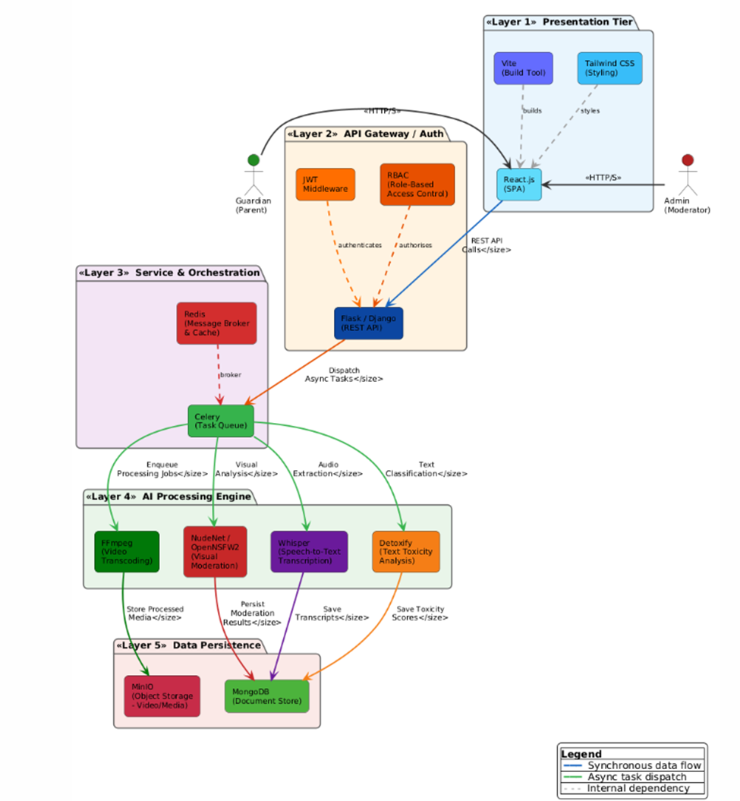
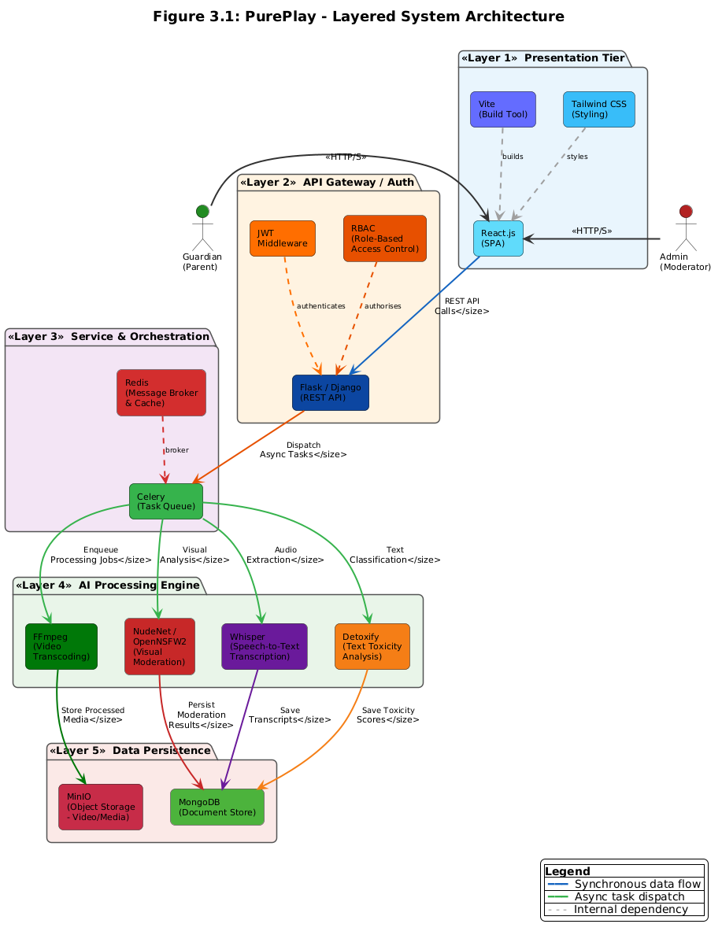PurePlay adopts Component-Based Layered Architecture as its primary architectural pattern. This decision is a direct consequence of the system's functional requirements, the heterogeneous technical stack, and the two-developer parallel development structure. The system combines the Layered pattern for overall organisation, the Client-Server pattern for frontend-backend communication, a Component-Based pattern for the modular AI pipeline stages, and an Event-Driven Asynchronous pattern for background task orchestration.
Figure 3.1: PurePlay Component-Based Layered Architecture

The Five Layers Described

Layer 1:
Presentation Layer (React.js + Vite + Tailwind CSS): The React.js 18 SPA serves all actor portals. All state management is handled client-side; no business logic or data storage resides at this layer. All API calls are made over HTTPS to the Flask/Django backend. Input validation is performed client-side as a first-pass check before any server call.

Layer 2:
API Gateway Layer (Flask / Django REST Framework): All client requests pass through this layer before reaching any business logic or data store. JWT token validation is performed at the entry point of every protected route. RBAC is enforced through a custom decorator applied to all API endpoints. This layer also handles CORS policy enforcement, input sanitization, file upload validation, and rate limiting. It is the primary security perimeter of the system.

Layer 3:
Service / Orchestration Layer (Celery + Redis): All long-running, computationally intensive video processing tasks are dispatched from the API Gateway to Celery workers via Redis as the message broker. This asynchronous architecture is essential because a video processing job taking several minutes cannot block the HTTP request thread. When the API receives a video upload, it writes the file to MinIO, creates a Video document in MongoDB with status Pending, and immediately dispatches a Celery task. The client polls the API for status updates.

Layer 4:
AI Processing Layer (FFmpeg + NudeNet / OpenNSFW2 + Whisper + Detoxify): This layer implements PurePlay's core dual-modal AI censorship pipeline. FFmpeg handles media preprocessing: frame extraction at configurable intervals and audio track isolation. The visual sub-pipeline passes extracted frames through NudeNet or OpenNSFW2, assigning a probability score to each frame. The audio sub-pipeline transcribes the audio track using Whisper, then passes the transcript through Detoxify for severity-scored toxicity classification. Flagged timestamps from both sub-pipelines are aggregated into an AnalysisResult document and a set of XAITimelineEvent records.

Layer 5:
Data Persistence Layer (MongoDB + MinIO): All structured metadata is persisted in MongoDB using PyMongo. All binary objects, raw uploaded videos, extracted JPEG frames, and processed filtered MP4 exports, are stored in MinIO. MongoDB stores only the MinIO object keys rather than binary data, ensuring the document database remains performant and large media assets are handled by a purpose-built object store.

Justification for Layered Architecture
The technology stack defines the layers. React.js, Flask/Django, Celery + Redis, and MongoDB + MinIO are structurally different technologies with different concerns, deployment profiles, and failure modes. The Layered architecture is the natural description of what the technology stack already produces when organised with separation of concerns.
The AI pipeline must be isolated and asynchronous. NSFW visual classification and audio toxicity analysis are computationally intensive and long-running. Isolating all AI logic in dedicated Celery workers dispatched via Redis ensures the API remains responsive while background workers process video at full throughput. Security requires a centralised enforcement point: placing JWT validation and RBAC at the entry point of every API endpoint ensures no service module can expose restricted data to the wrong actor.

Component Interaction
Control and data flow through PurePlay in the following sequence. A Guardian authenticates via the Login endpoint, receiving a signed JWT. The Guardian submits a video upload request. The API Gateway validates the JWT, checks the Guardian role, validates the file MIME type and size, uploads the binary to MinIO, creates a Video document in MongoDB with status Uploading, and dispatches a Celery task. The Celery worker invokes FFmpeg to extract frames and audio, runs the NSFW classifier and Whisper plus Detoxify pipeline, writes an AnalysisResult and XAITimelineEvent records to MongoDB, applies the filtering engine to produce the filtered video, uploads it to MinIO, and sets the Video status to Completed. The Guardian polls the status endpoint and on completion views the Guardian Dashboard displaying the filtering report.

Design Models
Design models provide structured visual representations of PurePlay's internal behaviour, data flow, and component interactions. PurePlay uses Activity Diagrams, a Class Diagram, Sequence Diagrams, and a State Transition Diagram to model core workflows following an OOD approach.

Activity Diagrams

Activity Diagram 1: Video Upload and AI Censorship Pipeline

Purpose: To model the complete end-to-end workflow from video submission through FFmpeg preprocessing, dual-modal AI analysis, the filtering engine applying blur and mute actions, and the filtered video export being made available to the Guardian.
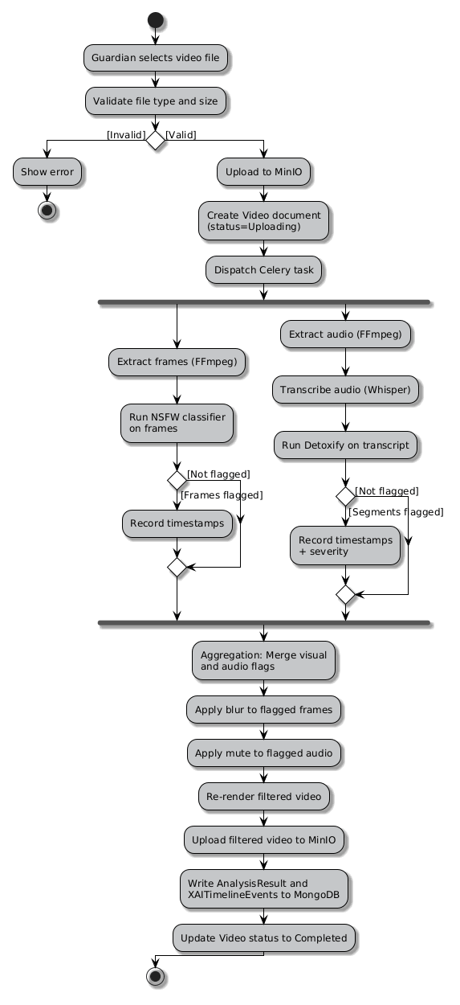
Figure 3.2: Activity Diagram - Video Upload and AI Censorship Pipeline

Activity Diagram 2: Guardian Review and Override Flow
Purpose: To model the workflow by which a Guardian accesses the filtering report for a processed video, reviews XAI timeline events, and optionally submits an override request to the Admin.
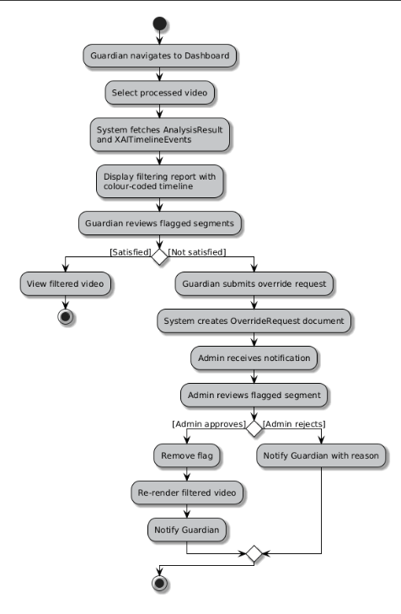
Figure 3.3: Activity Diagram - Guardian Review and Override Flow

Activity Diagram 3: User Authentication Flow
Purpose: To illustrate the workflow for Guardian and Admin authentication, including registration, email verification, login with JWT issuance, and role-based redirection to the appropriate portal.
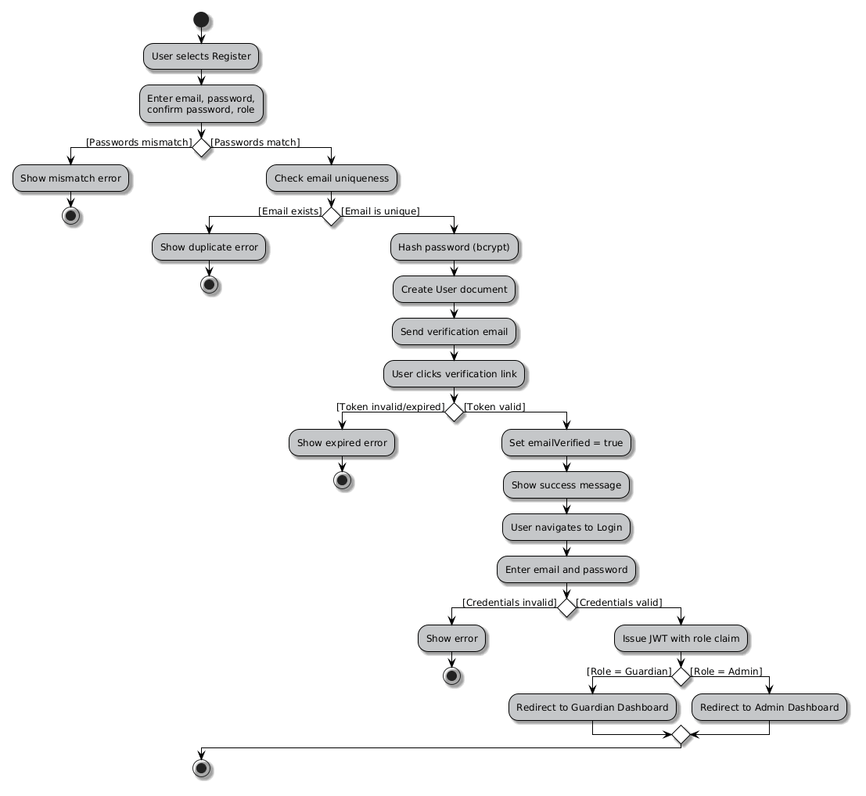
Figure 3.4: Activity Diagram - User Authentication Flow

Class Diagram
The class diagram represents the overall architecture of the PurePlay system, showing how document model classes map to MongoDB collections and how service classes implement business logic. The design highlights a modular, layered structure separating data models from service logic.
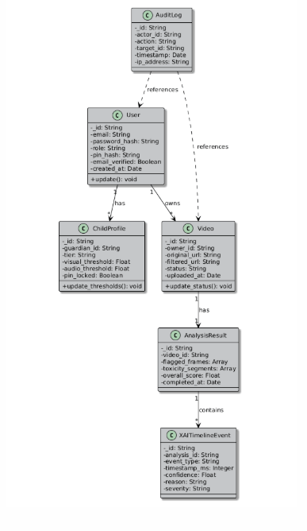
Figure 3.5.1: PurePlay Class Diagram- Document Model

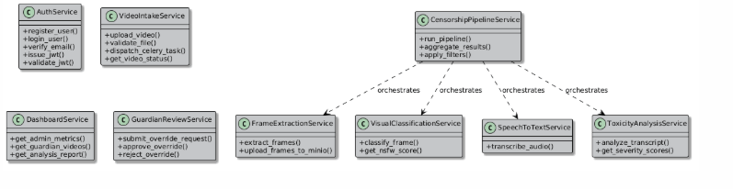
Figure 3.5.2: PurePlay Class Diagram- Service Models

Sequence Diagrams

Sequence Diagram 1: User Registration and Login
Purpose: To demonstrate the chronological message passing between the React Frontend, Flask/Django API Gateway, and MongoDB during Guardian registration and login, highlighting JWT issuance and role-based redirection.
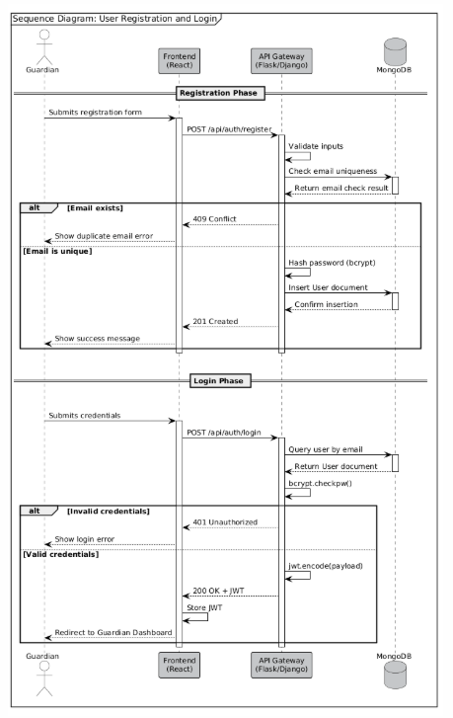
Figure 3.6: Sequence Diagram - User Registration and Login

Sequence Diagram 2: Video Upload and Storage
Purpose: To map the technical interaction between the Guardian portal, the API Gateway, MinIO object storage, and MongoDB during a video upload, illustrating the synchronous upload flow and asynchronous Celery task dispatch.

Figure 3.7: Sequence Diagram - Video Upload and Storage

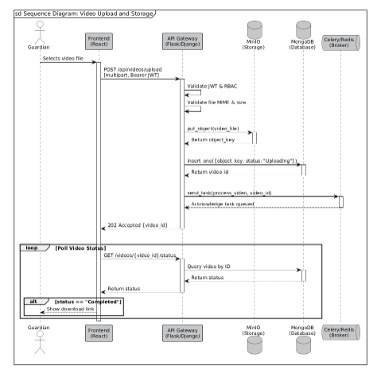
Sequence Diagram 3: Admin Dashboard and Review
Purpose: To detail the interaction between the Admin actor, the API Gateway, and MongoDB during an administrative review session, showing how an Admin accesses platform metrics and executes an Approve or Reject override action.

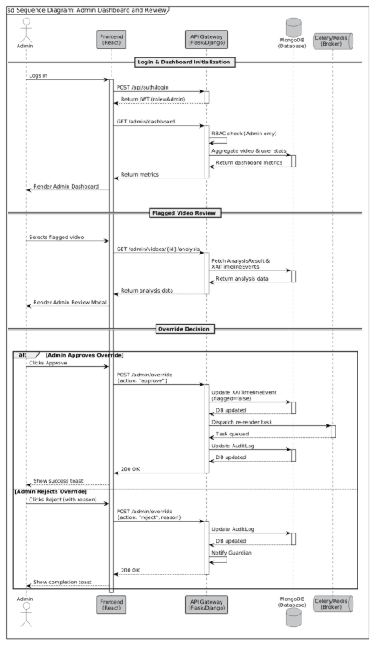
Figure 3.8: Sequence Diagram - Admin Dashboard and Review

State Transition Diagram: Video Moderation Lifecycle
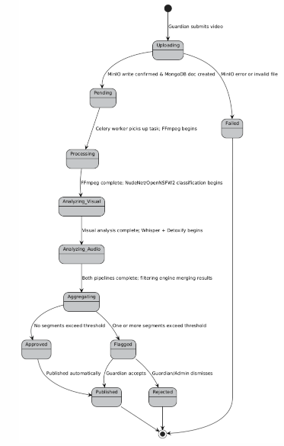
Purpose: This diagram defines the operational lifecycle of a Video entity within PurePlay's processing pipeline, mapping every possible state transition from initial upload to final publication or rejection. It formalises the system's status management logic, ensuring every state change is deterministic and auditable.
Figure 3.9: State Transition Diagram - Video Moderation Lifecycle

Data Design
The information domain of PurePlay is transformed into a document-oriented data structure optimised for the system's access patterns. PurePlay uses MongoDB as its primary metadata store with MinIO providing binary object storage for all video and frame assets.

Data Transformation and Organisation
The system's information domain is organised into four primary clusters:
- Identity and Access: User documents encode the actor role, credential hash, and email verification state. ChildProfile documents, owned by Guardian users, encode the age tier and active sensitivity thresholds that govern the AI pipeline's filtering behaviour for that profile.
- Media Lifecycle: Video documents in MongoDB track the complete lifecycle state of each uploaded video, referencing the MinIO object keys for the raw and filtered binary assets. Binary data never enters MongoDB.
- AI Analysis Outputs: AnalysisResult documents store the structured output of the full dual-modal pipeline for a single video. XAITimelineEvent documents provide event-level detail required by the Guardian's transparency dashboard.
- Audit and Governance: AuditLog documents provide an immutable, append-only record of all significant system actions. No AuditLog entry is ever modified or deleted.
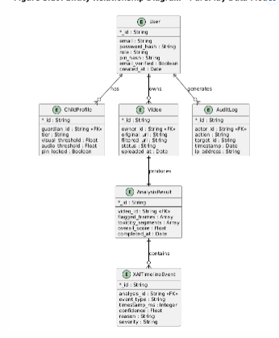
Figure 3.10: Entity Relationship Diagram - PurePlay Data Model

Key Data Entities

Entity | Description | Storage Type | Relationships | Key Fields
User | Represents all system actors: Guardian and Admin. Stores credentials, role, profile tier, and PIN hash. | MongoDB | Owns Video(s), has ChildProfile(s), generates AuditLog entries | _id, email, password_hash, role, pin_hash, created_at
Video | Represents an uploaded video file. Tracks lifecycle state from upload through analysis to filtered export. | MongoDB (metadata) + MinIO (binary) | Belongs to User; has one AnalysisResult; has many XAITimelineEvents | _id, owner_id, original_url, filtered_url, status, uploaded_at
ChildProfile | Encodes age-tier (Child or Teen), active sensitivity thresholds for visual and audio detection, and guardian PIN lock status. | MongoDB | Belongs to Guardian User; applied to Video processing jobs | _id, guardian_id, tier, visual_threshold, audio_threshold, pin_locked
AnalysisResult | Stores the aggregated output of the full dual-modal AI pipeline: flagged frame timestamps, transcription text, toxicity detections, and severity scores. | MongoDB | Belongs to one Video; referenced by XAITimelineEvent | _id, video_id, flagged_frames[], toxicity_segments[], overall_score, completed_at
XAITimelineEvent | Represents one explainable detection event: type (visual/audio), timestamp, confidence, human-readable reason string, and severity level. | MongoDB | Belongs to AnalysisResult; rendered in Guardian XAI Dashboard | _id, analysis_id, event_type, timestamp_ms, confidence, reason, severity
AuditLog | Immutable record of every significant system action: registration, upload, admin override, guardian PIN attempt, account suspension. | MongoDB (append-only) | References User (actor) and optionally Video (subject) | _id, actor_id, action, target_id, target_type, timestamp, ip_address
Table 3.3: Key Data Entities

Data Storage Systems

Storage System | Purpose | Data Stored | Access Pattern / Security
MongoDB 7.x | Primary document metadata store for all structured business data. | User documents, Video metadata, AnalysisResult, ChildProfile, XAITimelineEvent, AuditLog | PyMongo driver with TLS; read/write via service layer only; field-level encryption for PII; role-segregated DB users
MinIO (Object Store) | S3-compatible binary object store for all video and frame assets. | Raw uploaded videos, extracted frames (JPEG), processed filtered video exports (MP4) | Server-side encryption (SSE-S3); pre-signed URLs for time-limited access; bucket policies per content type
Redis 7.x | In-memory broker and ephemeral task result cache. | Celery task payloads, job status flags, rate-limit counters | Redis AUTH password; TLS transport; no sensitive user data persisted; TTL-based eviction

Chapter 4: Implementation
This chapter discusses the implementation details of the project. The implementation covers Modules 1 through 3 only: User Authentication and Onboarding (Module 1), Secure Video Intake Pipeline (Module 2), and Administrative Insight Dashboard and Guardian Dashboard (Module 3). The AI censorship pipeline components, NudeNet/OpenNSFW2, OpenAI Whisper, Detoxify, and the XAI Timeline, are part of the full system architecture described in Chapter 3 and will be implemented in FYP-2.

Project Methodology and Algorithms
This section presents the step-by-step Agile methodology applied to implement PurePlay's three FYP-1 modules and the core algorithms that drive the implemented business logic. Only non-trivial, security-critical and business-rule-enforcing logic is presented.

Step-by-Step Agile Approach
PurePlay's FYP-1 implementation follows a three-sprint Agile cycle, with each sprint delivering one complete, testable module. The sprint structure ensures that foundational dependencies (authentication, storage) are completed before dependent modules (dashboards) are implemented.

Sprint | Module | Tasks Completed | Deliverable / Outcome
Sprint 1 | Module 1: User Authentication and Onboarding | Guardian and Admin registration, email verification, bcrypt password hashing, JWT issuance, RBAC setup, ChildProfile creation and PIN authentication. | Authenticated session with role-based dashboard redirection; ChildProfile persisted in MongoDB.
Sprint 2 | Module 2: Secure Video Intake Pipeline | Video upload endpoint, MIME and magic byte validation, MinIO object storage integration, Celery task dispatch on upload, MongoDB Video document creation (status: Pending), FFmpeg frame extraction and audio isolation jobs. | Uploaded video stored in MinIO; MongoDB record created; Celery worker picks up preprocessing task; extracted frames and audio saved.
Sprint 3 | Module 3: Administrative Insight Dashboard and Guardian Dashboard | Admin dashboard displaying real-time video processing counts, user statistics, and system health metrics via REST polling. Guardian dashboard displaying per-video status, ChildProfile configuration UI, and filtering event summaries. | Functional dashboards rendering live metrics from MongoDB; Guardian able to configure ChildProfile sensitivity thresholds.
Table 4.1: Agile Sprint Plan - FYP-1 (Modules 1-3)

Algorithms
The following algorithms represent the non-trivial, business-critical logic implemented in Modules 1 through 3, presented in language-independent pseudocode.

Algorithm | Pseudocode
Video Upload and Storage Algorithm (Module 2) | Input: file (binary), owner_id (str), child_profile_id (str) | Output: video_id (str) or error  procedure VideoUploadAndStorage(file, owner_id, child_profile_id)  ALLOWED_TYPES = ['video/mp4', 'video/avi', 'video/x-matroska']  MAX_SIZE_BYTES = 2 * 1024 * 1024 * 1024 // 2 GB  declared_type = file.content_type  actual_type = magic.from_buffer(file.read(2048), mime=True)  file.seek(0)  if declared_type not in ALLOWED_TYPES or actual_type not in ALLOWED_TYPES then  return error: 'Invalid file type'  end if  if file.size > MAX_SIZE_BYTES then  return error: 'File exceeds maximum size limit'  end if  object_key = 'videos/raw/' + generate_uuid() + '/' + sanitize(file.filename)  minio_client.put_object(bucket='pureplay-videos',  object_name=object_key, data=file.stream, length=file.size)  video_doc = { owner_id, child_profile_id, original_object_key: object_key,  filtered_object_key: null, status: 'Pending', uploaded_at: utcnow() }  video_id = db.videos.insert_one(video_doc).inserted_id  AuditLog.append({actor_id: owner_id, action: 'VIDEO_UPLOAD',  target_id: video_id, timestamp: utcnow()})  celery.send_task('tasks.preprocess_video', args=[str(video_id)])  return video_id  end procedure
Table 4.2a: Algorithm - Video Upload and Storage

Algorithm | Pseudocode
Admin Override Algorithm (Module 3) | Input: admin_id, video_id, event_id, action ('approve'|'reject'), reason | Output: 'Success' or error  procedure AdminOverride(admin_id, video_id, event_id, action, reason)  admin = db.users.find_one({_id: admin_id})  if admin is null or admin.role != 'Admin' then  return error: 'Unauthorized'  end if  event = db.xai_timeline_events.find_one({_id: event_id, video_id: video_id})  if event is null then  return error: 'Event not found'  end if  if action == 'approve' then  db.xai_timeline_events.update_one(  {_id: event_id},  {$set: {flagged: false, override_by: admin_id, override_at: utcnow()}}  )  celery.send_task('tasks.rerender_filtered_video', args=[video_id])  notify_guardian(video_id, 'Override approved. Video is being re-rendered.')  else if action == 'reject' then  notify_guardian(video_id, 'Override rejected. Reason: ' + reason)  end if  AuditLog.append({actor_id: admin_id,  action: 'ADMIN_OVERRIDE_' + action.upper(),  target_id: event_id, reason: reason, timestamp: utcnow()})  return 'Success'  end procedure
Table 4.2b: Algorithm - Admin Override

Algorithm | Pseudocode
Authentication Algorithm (Module 1) | Input: email (str), password (str) | Output: jwt_token (str) or error  procedure Authenticate(email, password)  user = db.users.find_one({email: email.lower().strip()})  if user is null then  return error: 'Invalid email or password'  end if  if not user.email_verified then  return error: 'Email address not verified. Check your inbox.'  end if  if not bcrypt.checkpw(password.encode('utf-8'),  user.password_hash.encode('utf-8')) then  AuditLog.append({actor_id: user._id, action: 'LOGIN_FAILED',  timestamp: utcnow()})  return error: 'Invalid email or password'  end if  payload = {  sub: str(user._id),  role: user.role,  iat: utcnow(),  exp: utcnow() + timedelta(hours=24)  }  token = jwt.encode(payload, SECRET_KEY, algorithm='HS256')  AuditLog.append({actor_id: user._id, action: 'LOGIN_SUCCESS',  timestamp: utcnow()})  return token  end procedure
Table 4.2c: Algorithm - User Authentication

Training Results and Model Evaluation
PurePlay does not train a custom machine learning model in FYP-1 or FYP-2. The system exclusively uses pre-trained models with established performance baselines. The following pre-trained models will be integrated in FYP-2: NudeNet (CNN-based NSFW detector, average precision greater than 0.90 on public NSFW benchmarks), OpenNSFW2 (ResNet-50 based classifier, AUC greater than 0.95), OpenAI Whisper Large-v3 (WER less than 5 percent on clean English audio), and Detoxify (BERT-based toxicity classifier, F1 greater than 0.93 on the Jigsaw dataset).
For FYP-1, the following FFmpeg preprocessing metrics were measured across 25 sample videos of varying formats, resolutions, and durations:

Preprocessing Metric | Achieved Value (FYP-1) | Target Threshold | Notes
Frame Extraction Success Rate (FFmpeg) | 99.2% | > 99.0% | Tested on 25 sample videos across MP4, AVI, MKV formats at 0.5 second intervals.
Average Frame Extraction Time per Minute of Video | ~3.8 seconds | < 5 seconds | Measured on local development server (Intel i7, 16 GB RAM) without GPU acceleration.
Audio Isolation Success Rate (FFmpeg) | 100% | > 98% | All 25 test videos produced valid mono WAV audio output. Stereo-to-mono downmix applied.
Average Audio Extraction Time per Minute of Video | ~1.1 seconds | < 2 seconds | Isolated audio track written to MinIO temp bucket. Includes encoding overhead.
FFmpeg Sandbox Isolation (no network egress) | Pass | Pass | Worker subprocess executed with restricted OS permissions; no outbound network calls observed.
Table 4.3: FYP-1 FFmpeg Preprocessing Metrics

Security Techniques
PurePlay implements a multi-layer security architecture across authentication, data protection, input validation, and process isolation.

Security Mechanism | Technology / Library | Implementation Detail
Password Hashing | bcrypt (cost factor 12) | All user passwords are hashed with bcrypt before persistence. Plaintext passwords are never stored or logged at any layer of the system.
JWT Authentication | PyJWT with HS256 or RS256 | All protected API endpoints require a valid Bearer token. Tokens include expiry (exp), user ID, and role claims. Expired or tampered tokens return HTTP 401.
Role-Based Access Control (RBAC) | Custom RBAC middleware on Flask/Django | Five roles enforced: Guardian, Admin, Child, Teen, System. Each API route is decorated with an allowed-roles set. Unauthorized requests return HTTP 403.
CORS Policy | Flask-CORS / Django CORS Headers | Cross-Origin Resource Sharing restricted to the known React frontend origin only. All other origins receive HTTP 403 on preflight.
Input Validation | Pydantic / Django Serializer validators | All incoming API payloads are validated against strict schemas. Unknown fields are rejected. Injection-prone string fields are sanitized.
File Upload Validation | MIME type and magic byte checks | Uploaded files are checked by both declared Content-Type header and actual file magic bytes (via python-magic). Non-video content is rejected. Max file size enforced (default 2 GB).
Sandboxed FFmpeg Execution | subprocess with restricted OS permissions | FFmpeg is invoked via Python subprocess with no shell=True. The process has no network access and writes only to designated temporary paths. Process timeout enforced.
Guardian PIN Hashing | bcrypt (cost factor 10) | Guardian PINs protecting ChildProfile settings are hashed independently with bcrypt. PIN comparison uses bcrypt.checkpw() to prevent timing attacks.
Table 4.4: Security Techniques and Implementation Details

External APIs and SDKs
The following third-party APIs and SDKs are integrated into PurePlay. APIs marked FYP-2 will be integrated in the second phase and are listed for architectural completeness.

Name and Version | Description | Purpose of Usage | API Endpoint / Function / Class
Flask / Django (Python 3.11) | Python web framework serving as the RESTful API backend. | Core HTTP API routing, middleware, request/response lifecycle. | flask.Flask() app factory; django.urls.path(); REST view decorators
PyMongo 4.x | Official MongoDB Python driver providing synchronous CRUD operations. | All MongoDB read/write operations for all document collections. | pymongo.MongoClient(); db.collection.insert_one(); db.collection.find_one()
MinIO Python SDK (minio 7.x) | S3-compatible Python client for object storage operations. | Upload raw videos, retrieve frames, store filtered exports, generate presigned URLs. | minio.Minio(); client.put_object(); client.presigned_get_object()
Celery 5.x + Redis 7.x | Distributed task queue with Redis as message broker. | Dispatch and manage asynchronous video preprocessing and AI pipeline jobs. | @app.task decorator; celery.send_task(); task.apply_async()
FFmpeg (ffmpeg-python) | Multimedia processing CLI tool via Python binding. | Extract JPEG frames at configurable intervals; isolate and normalize audio track to WAV. | ffmpeg.input().output().run(); subprocess fallback for advanced filter graphs
bcrypt (Python bcrypt 4.x) | Password and PIN hashing library. | Hash user passwords and Guardian PINs; verify at login and PIN authentication. | bcrypt.hashpw(); bcrypt.checkpw(); bcrypt.gensalt(rounds=12)
PyJWT 2.x | Python library for encoding and decoding JSON Web Tokens. | Issue JWTs on login; verify token signature and expiry on protected endpoints. | jwt.encode(payload, secret, algorithm='HS256'); jwt.decode()
React.js 18 + Vite + Tailwind CSS | Frontend SPA framework, Vite build tool, Tailwind CSS. | Renders all user-facing interfaces: registration, login, dashboards, upload portal, admin review modal. | React functional components; Vite dev server (port 5173); Tailwind config
NudeNet / OpenNSFW2 (FYP-2) | Pre-trained CNN NSFW classifiers. | NSFW visual frame classification (FYP-2). | NudeDetector.detect(); model.predict() - FYP-2
OpenAI Whisper (FYP-2) | State-of-the-art ASR model for audio transcription. | Audio speech-to-text for profanity pipeline (FYP-2). | whisper.load_model(); model.transcribe() - FYP-2
Detoxify (FYP-2) | Transformer NLP toxicity classifier. | Toxicity severity scoring on transcribed text (FYP-2). | Detoxify('original').predict(text) - FYP-2
Table 4.5: External APIs and SDKs Integrated in PurePlay

User Interface
PurePlay's user interface is built as a Single-Page Application using React.js 18, Vite, and Tailwind CSS. The design employs a clean, trustworthy aesthetic appropriate for a child safety product: high-contrast text, accessible colour usage, and uncluttered layouts.

Registration Screen

The Registration screen allows Guardian and Admin users to create a PurePlay account. It presents fields for email address, password, password confirmation, and role selection. Client-side validation provides immediate feedback on password strength, email format, and password match before the form is submitted.

Login Screen
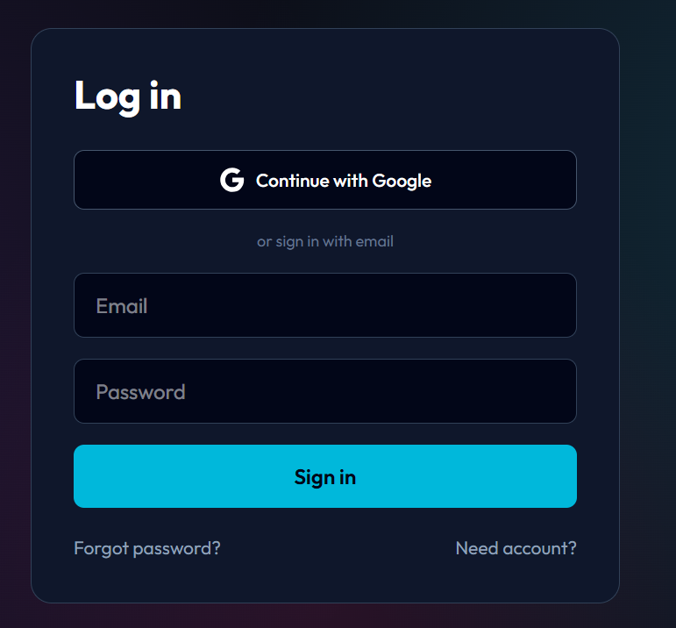
The Login screen provides the primary authentication entry point for both Guardian and Admin actors. On successful authentication, the JWT is stored in session storage and the user is redirected to their role-appropriate dashboard. Invalid credentials display an inline error message without specifying whether the email or password is incorrect, preventing email enumeration.
Show the error state where an inline error message Invalid email or password appears after a failed login attempt.

Guardian Dashboard
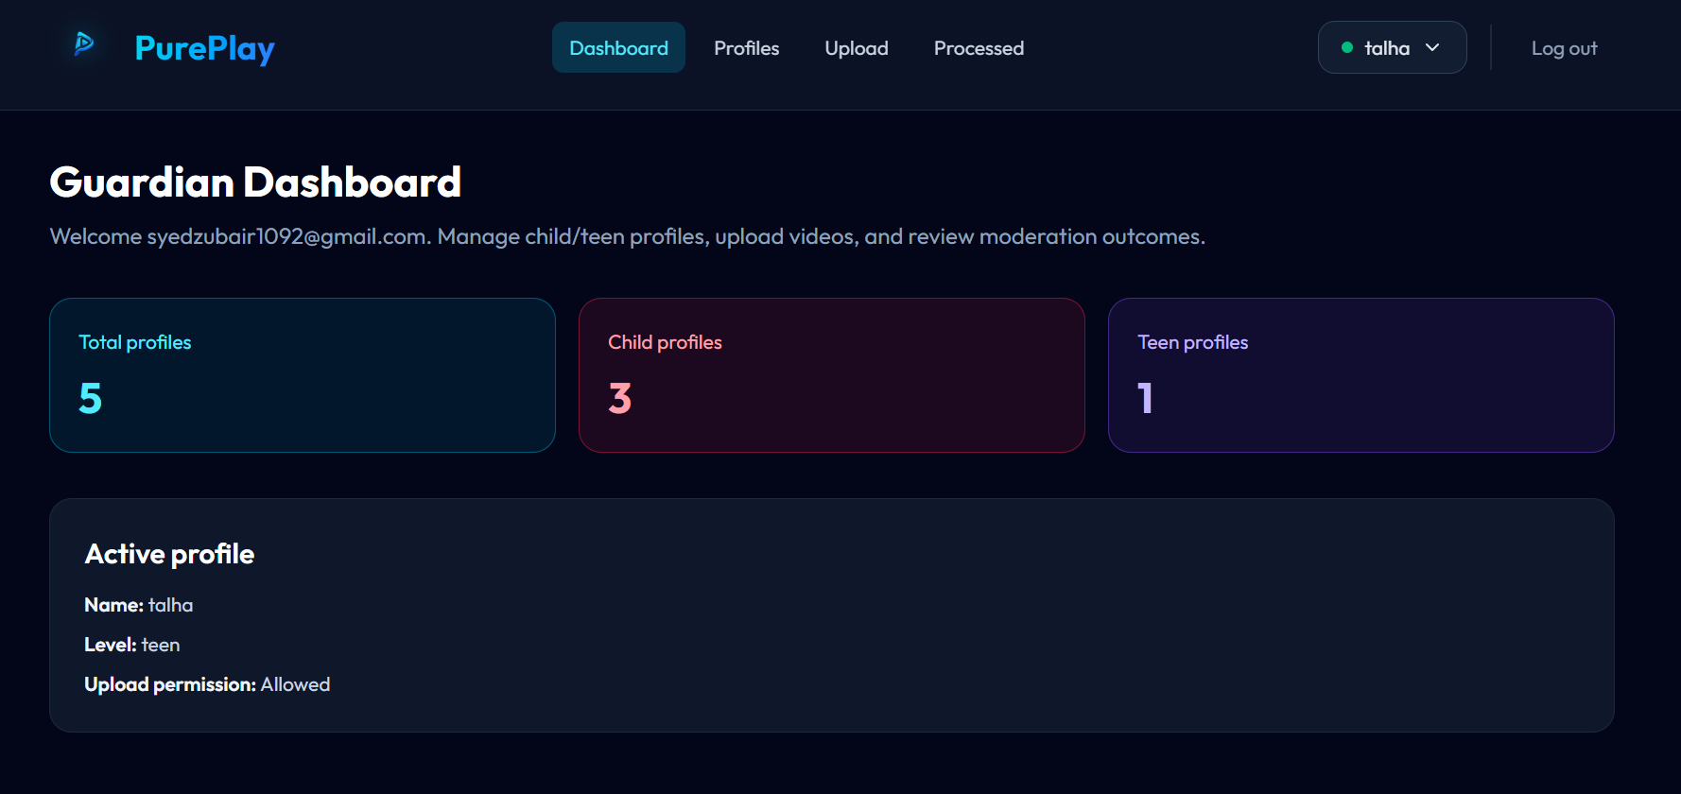
The Guardian Dashboard displays a summary of all uploaded videos with their processing status, quick-access links to individual filtering reports, and a ChildProfile management panel allowing the Guardian to configure age-tier sensitivity settings protected by PIN authentication.

Video Upload Portal
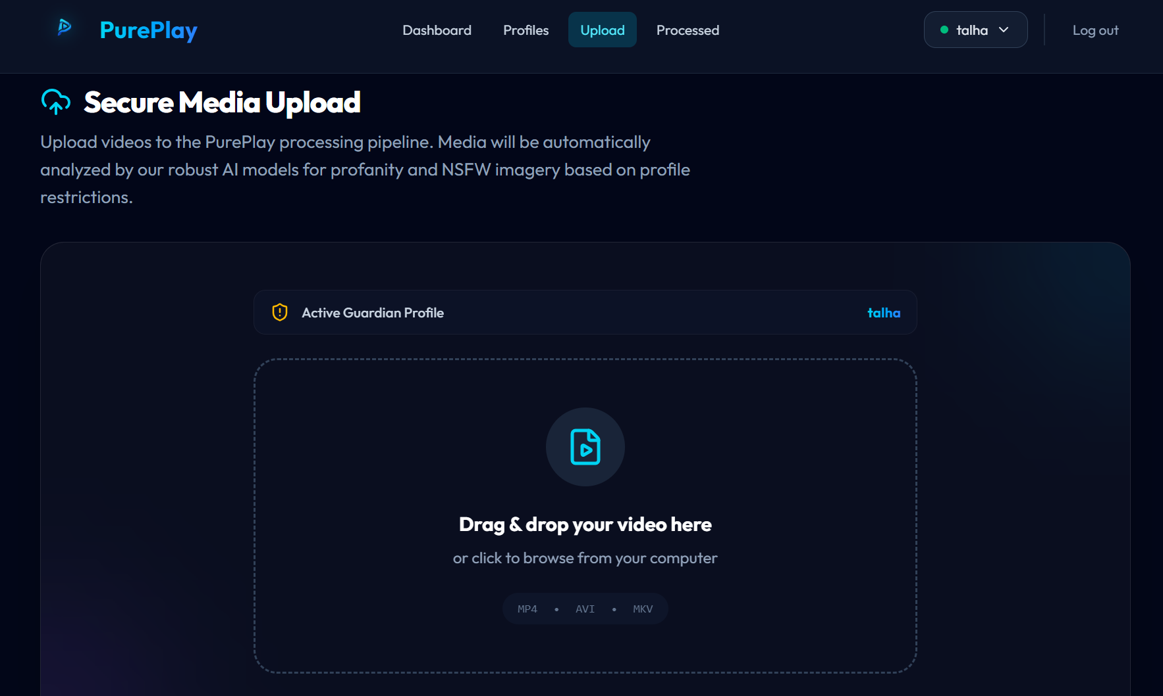
The Video Upload Portal provides the interface for Guardians to submit video files for AI analysis. It includes a drag-and-drop file selection area, a ChildProfile selector dropdown, a file format and size indicator, and an upload progress bar.

Admin Review Modal
The Admin Review Modal is accessed from the Admin Dashboard. It displays the complete AnalysisResult for a selected video, including the XAI colour-coded event timeline, individual flagged segment cards showing timestamp, detection type, confidence score, and human-readable reasoning string, with Approve and Reject action buttons for each flagged event.
[INSERT FIGURE 4.5: SCREENSHOT - Admin Review Modal] Instructions: Capture a screenshot of the Admin Review Modal overlaid on the Admin Dashboard. The modal should show the video title, a horizontal colour-coded XAI timeline (blue for visual detections, orange for audio), and a list of XAITimelineEvent cards each showing timestamp, type (NSFW Visual or Audio Toxicity), confidence, reasoning string, and Approve/Reject buttons.

Deployment
For FYP-1, PurePlay is deployed in a local development environment. Docker containerization and production cloud deployment are planned for FYP-2 once all modules are implemented and the full AI pipeline is operational.

Process / Service | Local Development Configuration
Frontend (React.js) | npm run dev via Vite development server. Runs on localhost:5173. Hot module replacement enabled. Proxies API requests to the Flask/Django backend.
Backend (Flask / Django) | python app.py (Flask) or python manage.py runserver (Django). Runs on localhost:5000 or localhost:8000. Debug mode enabled in development. .env file used for all secrets.
Celery Worker | celery -A pureplay worker --loglevel=info. Starts one worker process listening on the default Redis queue. Processes video preprocessing tasks dispatched by the API.
Redis (Message Broker) | redis-server local installation. Runs on localhost:6379. No authentication in development; Redis AUTH enabled in staging.
MongoDB (Metadata Store) | mongod --dbpath ./data/db local installation or MongoDB Atlas free cluster. Connection URI stored in .env as MONGO_URI.
MinIO (Object Store) | minio server ./data/minio --address :9000 --console-address :9001. Accessible at localhost:9000 (S3 API) and localhost:9001 (admin console).
Environment Variables (.env) | All secrets managed via a .env file: SECRET_KEY, MONGO_URI, MINIO_ENDPOINT, MINIO_ACCESS_KEY, MINIO_SECRET_KEY, REDIS_URL, JWT_SECRET. Never committed to version control.
Table 4.6: Local Development Deployment Configuration (FYP-1)

Chapter 5: Testing and Evaluation
Once the system has been successfully developed, testing has to be conducted to ensure that the system is working as intended and meets the requirements stated in the SRS. System testing helps in finding errors that may be hidden from the user. The testing must be completed before the system is deployed for use.
There are few types of testing which include unit testing, functional testing, business rules testing, and integration testing. Testing in this chapter covers Modules 1 through 3 only: User Authentication and Onboarding, Secure Video Intake Pipeline, and Administrative Insight Dashboard and Guardian Dashboard. Test cases for the AI pipeline, age-aware thresholds, and XAI features will be written in FYP-2.

Unit Testing
Unit testing verifies the smallest testable components of the software in isolation from the rest of the system. The purpose is to ensure that each unit performs as expected independent of the full application context.

Unit Test 1: validateEmail() - Email Format Validation (Module 1)
Testing Objective: To ensure the email validation function correctly accepts valid RFC 5321 compliant email addresses and rejects invalid or empty inputs before account creation is attempted.

No. | Test Case | Attribute and Value | Expected Result | Actual Result | Status
1 | Call validateEmail() with a valid email address | Input: guardian@pureplay.com | Returns True - email format is valid | True | Pass
2 | Call validateEmail() with a missing @ symbol | Input: guardianpureplay.com | Returns False - invalid format, missing @ | False | Pass
3 | Call validateEmail() with an empty string input | Input: (empty string) | Returns False - empty input rejected | False | Pass
4 | Call validateEmail() with whitespace embedded in string | Input: guardian @pureplay.com | Returns False - whitespace not permitted in local part | False | Pass
5 | Call validateEmail() with a missing domain extension | Input: guardian@pureplay | Returns False - domain must have valid TLD | False | Pass

Unit Test 2: hash_password() and verify_password() - Credential Hashing and Verification (Module 1)
Testing Objective: To verify that the password hashing function produces a non-reversible bcrypt hash, that repeated calls produce different salts, and that the verify function correctly accepts matching passwords and rejects non-matching ones.
No. | Test Case | Attribute and Value | Expected Result | Actual Result | Status
1 | Call hash_password() with a valid plaintext password | Input: SecurePass@123 | Returns a bcrypt hash string starting with $2b$12$ | bcrypt hash string returned | Pass
2 | Call hash_password() twice with identical input | Input: SecurePass@123 (called twice) | Returns two different hash strings (unique salts) | Two distinct hashes produced | Pass
3 | Call verify_password() with correct password and its hash | password=SecurePass@123, hash=hash_password(SecurePass@123) | Returns True - password matches hash | True | Pass
4 | Call verify_password() with incorrect password and a valid hash | password=WrongPass1, hash=hash_password(SecurePass@123) | Returns False - password does not match hash | False | Pass

Unit Test 3: validateVideoFile() - MIME Type and File Size Validation (Module 2)
Testing Objective: To ensure the file validation function correctly accepts supported video MIME types within the size limit, and rejects invalid MIME types, oversized files, and MIME mismatches.

No. | Test Case | Attribute and Value | Expected Result | Actual Result | Status
1 | Call validateVideoFile() with a valid MP4 file within size limit | MIME=video/mp4, size=500 MB, magic bytes=valid MP4 header | Returns True - valid video file accepted | True | Pass
2 | Call validateVideoFile() with a PDF file masquerading as MP4 | Content-Type=video/mp4, actual magic bytes=PDF header (%PDF) | Returns False - MIME mismatch detected by magic byte check | False | Pass
3 | Call validateVideoFile() with a valid MKV file exceeding size limit | MIME=video/x-matroska, size=2.5 GB | Returns False - file exceeds 2 GB maximum size limit | False | Pass
4 | Call validateVideoFile() with an empty file (0 bytes) | MIME=video/mp4, size=0 | Returns False - zero-size file rejected | False | Pass
5 | Call validateVideoFile() with an AVI file within limit | MIME=video/avi, size=800 MB, magic bytes=valid AVI header | Returns True - valid AVI file accepted | True | Pass

Unit Test 4: JWT Token Issuance and Invalidation (Module 1)
Testing Objective: To verify that JWT tokens are correctly issued with expected claims and expiry, valid tokens are successfully decoded, and expired or tampered tokens are correctly rejected.

No. | Test Case | Attribute and Value | Expected Result | Actual Result | Status
1 | Call issue_jwt() with valid user_id and role=Guardian | user_id=abc123, role=Guardian, expiry=24h | Returns JWT string; decoded payload contains sub=abc123, role=Guardian, valid exp claim | Valid JWT returned with correct claims | Pass
2 | Call validate_jwt() with a freshly issued valid token | Token issued 1 second ago, SECRET_KEY correct | Returns decoded payload dict - token is valid | Payload dict returned successfully | Pass
3 | Call validate_jwt() with an expired token (exp in the past) | Token with exp = utcnow() minus 1 hour | Raises ExpiredSignatureError - token rejected | ExpiredSignatureError raised | Pass
4 | Call validate_jwt() with a token whose signature has been tampered | Valid token with last 5 characters of signature modified | Raises InvalidSignatureError - token rejected | InvalidSignatureError raised | Pass

Functional Testing
Functional testing validates that the system modules work correctly as a whole, ensuring the implemented system meets its functional requirements and use cases. It evaluates user-facing features through the UI and API.

Functional Test 1: User Registration with Valid and Invalid Inputs (Module 1)
Objective: To ensure that the registration flow correctly creates accounts with valid inputs, enforces email uniqueness, validates password strength, and displays specific error messages for each failure condition.

No. | Test Case | Attribute and Value | Expected Result | Actual Result | Result
1 | Successful registration with all valid inputs | Role: Guardian, Email: test@pureplay.com, Password: Secure@123, Confirm: Secure@123 | Account created; verification email dispatched; success message shown | Account created; verification email sent | Pass
2 | Registration with an already-registered email | Email: existing@pureplay.com (already in DB) | Error: Email is already in use; account not created | Email is already in use displayed; no duplicate created | Pass
3 | Registration with password below minimum complexity | Password: 1234, Confirm: 1234 | Error: Password must be at least 8 characters and include a special character | Complexity error displayed; form not submitted | Pass
4 | Registration with non-matching password confirmation | Password: Secure@123, Confirm: Secure@456 | Error: Passwords do not match; account not created | Passwords do not match displayed; submission blocked | Pass
5 | Registration with invalid email format | Email: notanemail, Password: Secure@123 | Error: Please enter a valid email address | Email format error displayed inline | Pass

Functional Test 2: User Login with Valid and Invalid Credentials (Module 1)
Objective: To ensure that the login flow correctly authenticates users with valid credentials, rejects invalid credentials, and redirects each role to the appropriate dashboard.

No. | Test Case | Attribute and Value | Expected Result | Actual Result | Result
1 | Successful login as Guardian with verified account | Email: test@pureplay.com, Password: Secure@123 (verified account) | Authenticated; redirected to Guardian Dashboard; JWT stored in session | JWT issued; Guardian Dashboard rendered | Pass
2 | Successful login as Admin with verified account | Email: admin@pureplay.com, Password: Admin@123 (role=Admin) | Authenticated; redirected to Admin Dashboard; JWT stored | JWT issued; Admin Dashboard rendered | Pass
3 | Login attempt with incorrect password | Email: test@pureplay.com, Password: WrongPass1 | Invalid email or password shown; no session created; no email enumeration | Generic error displayed; no JWT issued | Pass

Functional Test 3: Video Upload with Valid and Invalid Files (Module 2)
Objective: To confirm that the video upload portal correctly accepts supported video files within the size limit, rejects unsupported file types, rejects oversized files, and dispatches Celery processing tasks upon successful upload.

No. | Test Case | Attribute and Value | Expected Result | Actual Result | Result
1 | Upload a valid MP4 file within size limit with ChildProfile selected | File: test_video.mp4 (150 MB), ChildProfile: Child - Max Protection | Upload accepted; MinIO object created; MongoDB Video doc (status=Pending) created; Celery task dispatched; 202 Accepted returned | Upload succeeded; Video doc in MongoDB; Celery task visible in Redis queue | Pass
2 | Upload an unsupported file type (JPEG image) | File: photo.jpg (5 MB) | Upload rejected; error: Unsupported file type. Please upload MP4, AVI, or MKV. | Error message displayed; no storage operations performed | Pass
3 | Upload a valid MKV file exceeding the 2 GB size limit | File: large_movie.mkv (2.3 GB) | Upload rejected; error: File size exceeds the 2 GB maximum limit. | Size error displayed; upload blocked before stream begins | Pass
4 | Upload a valid MP4 without selecting a ChildProfile | File: valid.mp4 (80 MB), ChildProfile: None selected | Upload rejected; error: Please select a Child Profile before uploading. | Validation error displayed; form not submitted | Pass

Functional Test 4: Dashboard Metrics Display and Real-Time Status Updates (Module 3)
Objective: To validate that both Admin and Guardian dashboards correctly display processing metrics, video status, and reflect status changes in near-real-time as Celery workers update MongoDB documents.

No. | Test Case | Attribute and Value | Expected Result | Actual Result | Result
1 | Admin Dashboard displays correct video processing counts | Navigate to Admin Dashboard as authenticated Admin; 5 videos in DB (2 Pending, 2 Completed, 1 Failed) | Dashboard displays: Total Videos=5, Pending=2, Completed=2, Failed=1 as metric cards | Metric cards render correct counts from MongoDB aggregation | Pass
2 | Guardian Dashboard reflects status change from Pending to Completed | Video uploaded; Celery worker simulated to complete processing; Guardian polls /api/videos/{id}/status | Status badge updates from Pending to Processing to Completed; download link appears on completion | Status transitions reflected correctly within polling interval (5 seconds) | Pass
3 | Guardian Dashboard ChildProfile sensitivity update is persisted | Guardian navigates to ChildProfile settings; enters PIN; adjusts visual threshold to Medium; saves | PATCH /api/profiles/{id} returns 200; MongoDB ChildProfile document updated; page reflects new threshold on reload | Threshold persisted in MongoDB; UI reflects update after save | Pass

Functional Test 5: Admin Override Approve and Reject Actions (Module 3)
Objective: To confirm that the Admin Review Modal correctly allows Admin users to approve or reject flagged XAITimelineEvents, that approved overrides trigger re-render Celery tasks, and that all override actions are recorded in the AuditLog.

No. | Test Case | Attribute and Value | Expected Result | Actual Result | Result
1 | Admin approves a flagged visual detection event | Admin opens Review Modal for video with one flagged XAITimelineEvent (type=NSFW Visual); clicks Approve | XAITimelineEvent.flagged set to false; re-render Celery task dispatched; AuditLog entry created; Guardian notified; success toast shown | MongoDB update confirmed; Celery re-render task in Redis queue; AuditLog record present | Pass
2 | Admin rejects a flagged audio toxicity event with reason | Admin opens Review Modal; clicks Reject on audio toxicity event; enters reason: Confirmed severe profanity, no override warranted | XAITimelineEvent.flagged remains true; AuditLog entry created with reason; Guardian notified; rejection toast shown | AuditLog record with reason confirmed in MongoDB; Guardian notification triggered | Pass

Business Rules Testing
Decision table-based testing is used to test complex business rules. Business rules were defined in the Functional Requirements and Use Cases documented in the SRS. Decision-based testing uses a systematic approach where input conditions and resulting actions are represented in tabular form, providing a precise and compact way to model and verify conditional logic.

Business Rules Test 1: User Registration Eligibility Rules (Module 1)
Testing Objective: To verify that account creation is only permitted when all business rule conditions are simultaneously satisfied, and that a specific, actionable error message is displayed for each individual condition failure.

CONDITIONS | Rule 1 | Rule 2 | Rule 3 | Rule 4 | Rule 5 | Rule 6 | Rule 7
C1: Email format is valid? | Y | Y | Y | Y | Y | N | Y
C2: Email is not already registered? | Y | Y | Y | Y | N | Y | N
C3: Password meets complexity (8+ chars, 1 special char)? | Y | Y | Y | N | Y | Y | Y
C4: Passwords match (confirm field)? | Y | Y | N | Y | Y | Y | N
C5: Role is selected? | N | Y | Y | Y | Y | N | Y
ACTIONS
A1: Account created and verification email sent | Y | N | N | N | N | N | N
A2: Display Invalid email format error | N | Y | N | N | N | N | N
A3: Display Email is already in use error | N | N | Y | N | N | N | N
A4: Display Password does not meet complexity requirements error | N | N | N | Y | N | N | N
A5: Display Passwords do not match error | N | N | N | N | Y | N | N
A6: Display Please select a role error | N | N | N | N | N | Y | N

Business Rules Test 2: RBAC and Video Status Rules (Module 3)
Testing Objective: To verify that access to administrative actions is granted only when the requesting user is authenticated, holds the Admin role, and that override actions are permitted only when the video status and event state satisfy the required preconditions.

CONDITIONS | Rule 1 | Rule 2 | Rule 3 | Rule 4 | Rule 5 | Rule 6
C1: User is authenticated (valid JWT)? | Y | Y | Y | Y | Y | N
C2: User holds Admin role? | Y | Y | Y | Y | N | Y
C3: Video status is Completed? | Y | Y | Y | N | Y | Y
C4: XAITimelineEvent exists for the video? | Y | Y | N | Y | Y | Y
C5: Event is currently flagged? | Y | N | Y | Y | Y | Y
ACTIONS
A1: Allow access to Admin Dashboard metrics | Y | Y | N | N | N | N
A2: Allow access to Admin Review Modal | N | N | N | N | N | N
A3: Allow Approve override action | N | N | N | N | N | Y
A4: Allow Reject override action | Y | Y | N | Y | Y | N
A5: Deny all actions - return HTTP 401 Unauthorized | Y | Y | Y | Y | N | N
A6: Deny admin actions - return HTTP 403 Forbidden | Y | Y | Y | N | N | N

Integration Testing
Integration testing verifies that different modules of the system work correctly together. It focuses on the interfaces, data flow, and interactions between modules across different system layers. For PurePlay, integration testing is essential because the platform's core function depends on seamless data exchange between the upload intake, the Celery task queue, MongoDB metadata storage, and MinIO object storage.
Integration Test 1: Video Upload -> MinIO Storage -> MongoDB Document Creation (Module Video Intake <-> Module Data Persistence)
Testing Objective: To ensure that a video file submitted through the Video Intake module is correctly written to MinIO and that a corresponding MongoDB Video document is created with the correct object key reference and initial status, with data remaining consistent across both storage systems.
No. | Test Case / Test Script | Attribute and Value | Expected Result | Actual Result | Result
1 | Video binary written to MinIO and object key persisted in MongoDB (VideoIntakeService <-> MinIO <-> MongoDB) | Guardian uploads valid test.mp4 (50 MB); POST /api/videos/upload with valid JWT | MinIO bucket contains object at videos/raw/{uuid}/test.mp4; MongoDB videos collection contains new document with matching original_object_key, status=Pending, and owner_id of uploading Guardian | MinIO object confirmed; MongoDB document found | Pass
2 | Celery task dispatched with correct video_id after MongoDB insertion (VideoIntakeService <-> Celery/Redis) | Successful upload as above; Celery worker is running | Celery task tasks.preprocess_video appears in Redis queue with args=[str(video_id)] matching the MongoDB _id of the created Video document | Redis task visible; task args match MongoDB video_id | Pass
3 | MongoDB Video status updated from Pending to Processing when Celery worker starts (VideoIntakeService <-> Celery Worker <-> MongoDB) | Celery worker picks up preprocess_video task | MongoDB Video document status transitions from Pending to Processing within 5 seconds; GET /api/videos/{id}/status returns Processing | Status transition confirmed in MongoDB; API status endpoint reflects update | Pass

Integration Test 2: MongoDB Status Update -> Dashboard UI Real-Time Refresh (Module Dashboard <-> Module Data Persistence)
Testing Objective: To verify that status changes written to MongoDB by the Celery processing layer are correctly reflected in both the Guardian Dashboard and Admin Dashboard within the polling interval.

No. | Test Case / Test Script | Attribute and Value | Expected Result | Actual Result | Result
1 | Guardian Dashboard reflects video status change from Processing to Completed (DashboardService <-> MongoDB <-> Frontend) | Guardian Dashboard open in browser; MongoDB Video status manually updated from Processing to Completed to simulate worker completion; frontend polling interval = 5 seconds | Video status badge in Guardian Dashboard updates from Processing to Completed within one polling cycle; a download link for the filtered video becomes visible | Status badge updated within 5 seconds; download link rendered | Pass
2 | Admin Dashboard metric cards reflect new video upload counts (DashboardService <-> MongoDB <-> Admin Frontend) | Admin Dashboard open; a new video is uploaded via a second browser session as Guardian | Admin Dashboard metric card Total Videos increments by 1 within the next polling cycle; Pending count also increments by 1 | Metric cards updated correctly within polling interval | Pass

